Mitchell’s Musings
Third Quarter, 2013
Formatting may differ from originals which are posted on
www.employment.policy.org
Mitchell’s Musings 7-1-13: Lessons of the Week
Daniel J.B. Mitchell
The chart below shows the S&P 500 index. It indicates that the stock market was booming along until mid-May. Then came fears that maybe the Federal Reserve would end its purchases of various financial assets and the rise halted. When Fed chair Ben Bernanke indicated explicitly in the third week of June that the purchases might indeed be tapered off - assuming the economy continued to improve - the stock market tanked. It was revived somewhat (at this writing) by a Bureau of Economic Analysis report indicating that real GDP in the first quarter rose more slowly than indicated in previous estimates.
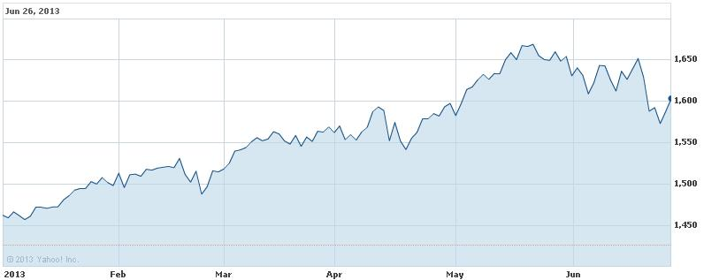
So what are the lessons from this episode? First, although there have been complaints in some financial circles that the Fed was too aggressive in its efforts to stimulate the economy, the mere thought that the policy might halt created a panic. The objections to Fed stimulus were all in the abstract. But when push came to shove, it appears that Wall Street thinks the stimulus actually is necessary and fears any premature termination. The seeming rebound when the weak GDP report came out in fact gave hope to market transactors that the Fed would heed the fragility of the economy and would not pull back too soon.
A second lesson comes from the GDP release itself. We have noted in prior musings that there is little virtue in having rushed preliminary data releases on key economic indexes that will later be revised. The initial estimate of real GDP put the annual rate of real growth for the first quarter of 2013 at 2.5%. That figure was then revised down to 2.4% in the second estimate. The most recent number is 1.8%. If the Fed did make policy judgments using the earlier estimates – not necessarily what actually happened – what was the gain in putting out rough preliminary estimates? Why should we encourage policy making based on shaky data?
Critics of Fed stimulatory efforts have largely focused on fears of inflation. They acknowledge that inflation has been quite low since the Great Recession; the same media release that contained the real GDP figure also showed the gross domestic purchases price index rising at only a 1.2% annual rate. But critics are convinced that the credit creation activities of the Fed will inevitably produce rapid inflation, albeit at a date uncertain. The third lesson – one which we have pointed to periodically – is that financial markets are expecting no such thing. As the chart below shows, the spreads between inflation-indexed Treasuries and conventional Treasuries have not been suggesting high future inflation and in fact have been showing a downward trend over the past few months.
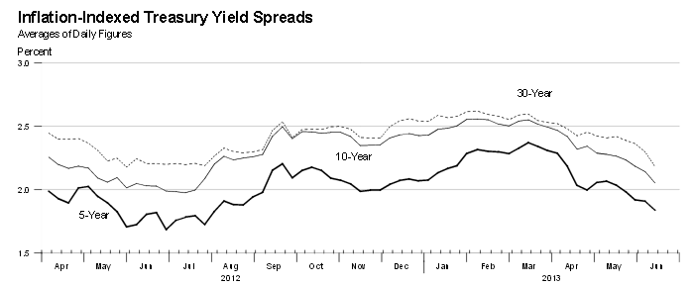
A fourth lesson comes from what was ignored. While much attention was focused on the GDP media release, another release that came out around the same time was ignored. As the charts on the next page show, that release indicated that the march of the U.S. to ever-greater net debt to the rest of the world – thanks to our trade imbalance- continues. The negative impact on jobs in the U.S. – particularly in manufacturing – thus continues, too.
As we have noted in previous musings, much of the imbalance is linked to undervalued currencies. While the U.S. takes a laisser-faire view of exchange rates, other countries do not. Although the focus in this regard has been on China, policies of holding down or reducing national currency values are not confined to that country. The euro-zone countries have been content to wallow in austerity, but - of late - Japan has not. And as the can also be seen below, the yen/dollar ratio began to climb (the yen depreciated relative to the dollar) when Japan decided its economy needed stimulation. To Japan, stimulation means more exports.
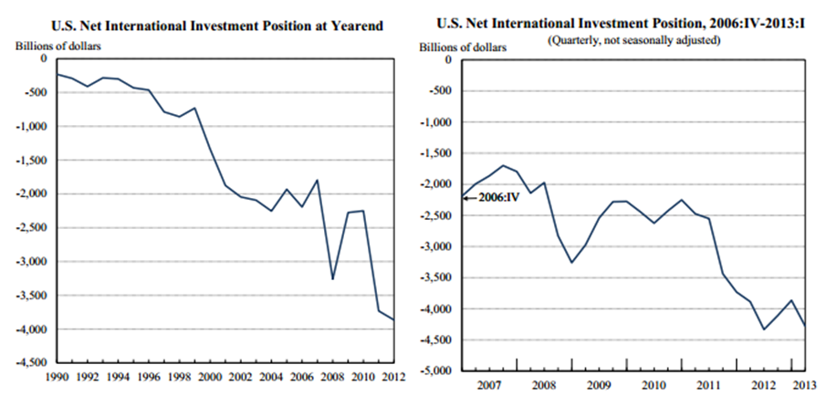
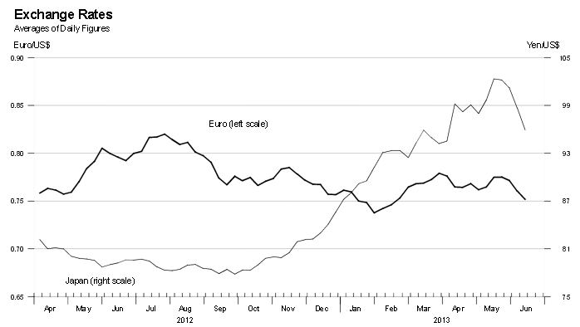
I haven’t heard any comments from the legislative or administrative branches in Washington about exchange rates or about the sluggish recovery as reflected in the slow advance of real GDP, whatever the estimate may be. From time to time, there is official rhetoric about “good jobs” and about bringing manufacturing back. But the disconnect between those concerns and U.S. international economic policy (or lack thereof) is striking. Calls for a proactive American policy concerning foreign exchange rates policies are met with charges of “protectionism” or vague statements about living in a global economy. On the upcoming Independence Day, it would be nice to see some signs of independent thinking among the powers-that-be.
Mitchell’s Musings 7-8-13: Labor Non-Reporting
Daniel J.B. Mitchell
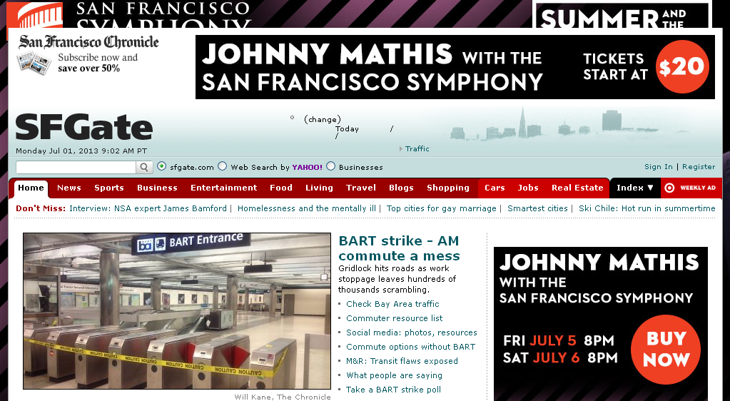
Back in the day, there used to be labor reporters who were knowledgeable about collective bargaining and who followed developments and policy related to labor relations. Of course, the Internet has resulted in a decline in newspaper reporting of all types. But the decline of the labor reporter predates the impact of the Internet and was really a product of the decline of organized labor as a major force in the private sector.
There are two key results of the absence of labor reporters today. Above you see a screenshot from the webpage of the San Francisco Chronicle of July 1, 2013. It reports on the impact of a transit (subway) strike that began on that date on commuting. But actual coverage of strike issues is rather limited. You will find claims and counterclaims by the union and management sides and references to state government intervention. You won’t find information about how California public policy on government labor relations disputes is different from that in many other jurisdictions. (Public sector employees in California generally have the right to strike unlike those in many other parts of the country or at the federal level.)
You won’t find much information about the power of the governor to intervene in this dispute. (The governor can impose a temporary injunction but his options to require some sort of dispute settling mechanism beyond the injunction are very limited.) You won’t find information about why – since the governor did have that limited authority – he chose (at least at the start of the strike) not to use it. He made that choice although the union involved apparently requested he impose an injunction. You won’t find analysis of why the union paradoxically might have wanted the governor to enjoin (temporarily) its own right to strike.
California has a somewhat higher unionization rate than the U.S. average but almost all that differential is due to relatively high unionization in the public sector. Apparently, however, the state’s public sector differential is not sufficient to produce the kind of labor reporting that might have occurred, say, a quarter century ago. Nor is there heavy competition among newspapers that might encourage such reporting.
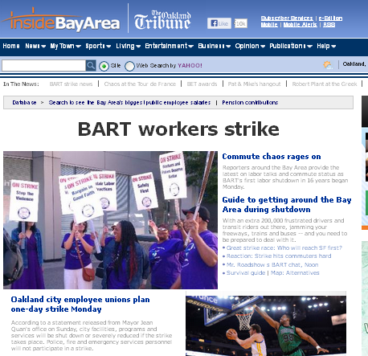
At one time in the state’s history, the Oakland Tribune was an influential force in state politics. (Oakland is serviced by the same BART train system that services San Francisco.) Today, the paper is part of a group of local dailies. The Tribune once occupied a high rise building that dominated the City of Oakland; today the building – although architecturally interesting – is no longer occupied by the paper and (I believe) is empty. As the screenshot on the previous page suggests, the reporting to be found in the Tribune more or less mirrors what was in the Chronicle. You won’t find analysis of the strike or public policy on government labor relations in California, although – as the screenshot shows – there was also another strike in effect of city workers in Oakland.
I found similar reporting on the transit strike in the San Francisco Examiner. There was some information about strike issues, at least as described by the labor and management sides. There wasn’t anything about state public policies, but there was mention of state mediation efforts. How state mediators operate or how they become involved in labor disputes was not explained. Nonetheless, at least one newspaper was providing news that went beyond simply reporting the effects of the strike on commuters and what the parties said.
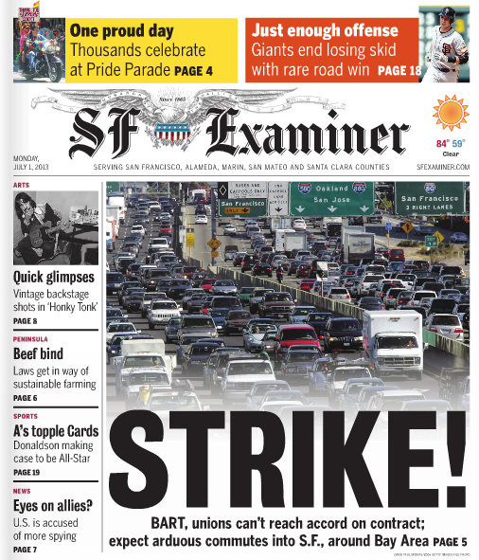
The fact that the Examiner had more information than the other two newspapers suggests that there is a potential reader interest in detailed discussion of public sector labor relations issues, if only because strikes occur from time to time. In short, the interest is still there but not the specialized labor reporters that once catered to that interest. There isn’t a simple remedy for this situation. However, there are people with labor expertise in academia. Indeed, the Labor and Employment Relations Association (LERA) and the Employment Policy Research Network (EPRN) can be helpful to news reporters in making referrals.
Even if the referrals cannot answer specific questions about this particular labor dispute, they can provide some guidance on questions for reporters to ask. We noted some questions above, e.g., why the governor – although he has the power to halt the strike temporarily - has chosen not to use his authority. In addition, high-profile strikes seem inevitably to result in estimates of their “costs.” This one was no exception, as can be seen below. However, exactly how the estimate of $73 million per day was derived is not clear or questioned in the news report. Nor is the figure put in perspective, i.e., how big is $73 million compared to the daily GDP of the Bay Area?
----------------------------------------------------------------------------------------------------------------------------------------
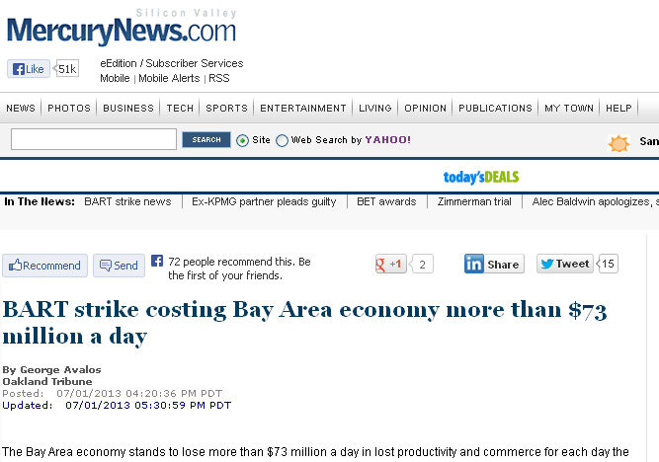
----------------------------------------------------------------------------------------------------------------------------------------
So what lessons should be drawn? Media reporters need to go beyond what the parties say about their dispute. Both sides have an interesting in spinning public opinion and in using the news media to meet their bargaining objectives. There are, however, neutral observers in the academic world who might provide some insights. And what about those academics? They need to make themselves available when major disputes occur to fill in where once labor reporters were available to provide analysis.

Note: This musing of 7-8-13 was actually posted on July 2, 2013.
Mitchell’s Musings 7-15-13: Do What I say


Daniel J.B. Mitchell
There are now many, many articles about Bradley Manning – the Wikileaks source – and about Edward Snowden – the NSA surveillance leaker. Virtually all of these articles have to do with issues of national security, privacy, civil liberties, etc. So let’s make it clear from the outset that this musing is about none of those issues. If you want to read a debate about those issues, you will have no trouble finding it elsewhere.
Another issue has gotten less attention and it’s the ultimate question in the field of employment. That question is how do you get folks to do what you want? How do you get them not to do what you don’t want? Clearly, neither Manning nor Snowden did what the government wanted them to do. It’s very unlikely that either individual was under the illusion that what they were doing was what the government wanted. It is virtually certain in fact that both individuals understood they were doing something that the government didn’t want, i.e., leaking secret information.
One thing we know. Just telling folks what to do or what not do doesn’t guarantee they will follow instructions. How many times have you heard the safety instructions before taking off in an airplane? You are told that you should evacuate quickly in an emergency and should not take your belongings. Yet when just such an emergency happened in the recent plane crash at the San Francisco airport, passengers emerged from the aircraft – which was on fire – with personal belongings including roller bags. One passenger reported retrieving his bags first and then getting his child!
As noted above, in the employment setting there has long been recognition of the problem of getting workers to do what you want and not to do what you don’t want. In broad terms, the “solution” (I use quotation marks because there is no perfect solution) involves some mix of supervision and systems of reward and penalty. Supervision can involve anything from intense monitoring to clever motivational approaches that, in effect, encourage self-monitoring. Rewards and penalties can involve such things as piece rates or firing.
Particularly in the public sector, when the issue is doing work in house or outsourcing it to some other – often private – entity, ultimately the argument revolves around claims of efficiency. Would the public mission be carried out more efficiently if done directly by the agency tasked with carrying it out? Or should that agency employ some other entity to do the actual work? What you are asking – from the employment viewpoint – when those questions come up is under which regime are the managerial decisions of supervision and/or rewards and penalties better made and carried out?
Given that perspective, what do the Manning and Snowden cases tells us? Manning was a private in the U.S. Army who had access to official – but secret – databases. It is a given that he didn’t do what the Army wanted in downloading documents and passing them on to Wikileaks. We have no way of knowing how he viewed the probabilities of being caught. But that concern is no different from other workplace situations.
Employees who embezzle from their employers, for example, are likely aware that they could possibly be caught but apparently think they probably won’t be. They might believe the probability of being caught is low if the safeguards built into the managerial system seem to be loose. It seems there was no automatic flag built into the government computer databases that would flag an Army private downloading a vast quantity of files. Manning might have taken that lack of control to suggest that no one was looking and that he wouldn’t be caught.
Now you might argue that the absence of automatic flags/controls in the Manning case proves that outsourcing is better than in-house production. If only the government had outsourced its database accessing to some private entity, controls would have been put in place by that entity to prevent leaks. A private, profit-making entity would have understood that it could lose the contract and perhaps be penalized if leaks occurred. So the profit motive would create the needed incentive to implement safeguards against leaking.
The only problem with that argument is that Snowden worked for a private, profit-making entity and was not employed directly by the government. In his case, the task was outsourced. But the private entity for which he worked - Booz Allen Hamilton, Inc. - evidently did not have controls in place that would have prevented his leaks. What the Snowden case shows is that using a private contractor by itself simply changes the locus of where control is needed. If the public agency does its task (in house), it has to control the activities of its employees directly. If it outsources, the public agency has to control the contractor so that the contractor controls its employees appropriately.
What is the lesson to be learned from the Manning and Snowden episodes, therefore, from the employment perspective? Most importantly it is that the decision in the public sector either to do things in house or to outsource should not be viewed ideologically. Manning’s leak doesn’t prove that outsourcing is preferable. Snowden’s leak doesn’t prove doing things in house is optimal. But the two cases combined show that a) no system will work perfectly and all the time, and that b) whether a public agency chooses carry out its mission in house or through outsourcing, it has to implement appropriate, albeit inevitably imperfect, managerial controls. If the decision is in house, the controls must be of the workers. If the decision is to outsource, the controls must be of the contractor.
Mitchell’s Musings 7-22-2013: Keynesian Qualifications
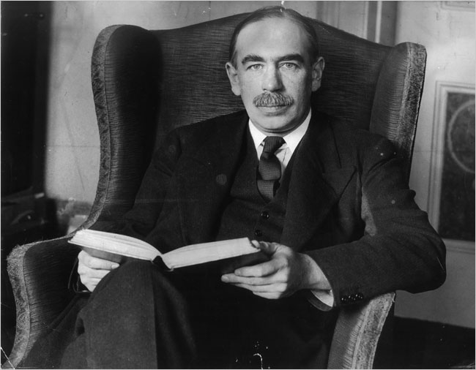
Keynes
Daniel J.B. Mitchell
An interesting article has appeared on the San Francisco Federal Reserve Bank website comparing macro-level nominal wage behavior during and after the Great Recession with wage behavior in prior episodes. The article looks at nominal wage change and finds – as have many others – that during recessions and soft labor markets, downward nominal wage rigidity retards explicit wage cuts that a drop in labor demand might otherwise cause. So the proportion of workers with zero wage increases rises for a time.
Earlier work in this field usually attributed such downward nominal wage rigidity to some combination of money illusion and worker resentment – if wages are cut explicitly – that could undermine morale and productivity. At one time, notably back in the days when John Maynard Keynes was writing, it was common to see the mechanism for such rigidity as related to union contracting and resistance. In modern American circumstances, however, the unionization rate is very low in the private sector so the more behavioral/psychological explanations tend to be favored more recently.
The chart below from the paper illustrates the effect of downward nominal wage rigidity. Each recession shown on the chart caused a rise in the proportion of workers with frozen wages. Then, with a lag, the proportion began to decline. In that respect, the Great Recession of 2008 was consistent with the past. However, as the chart also shows, the freeze effect was more pronounced in the most recent recession so that the percent of workers with zero wage increases became particularly high.
- - - - - - - - - - - - - - - - - - - - - - - - - - - - - - - - - - - - - - - - - - - - -
Proportion of Workers Experiencing Zero Wage Increases
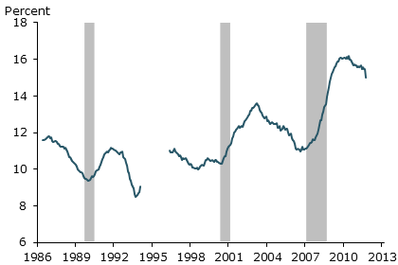
- - - - - - - - - - - - - - - - - - - - - - - - - - - - - - - - - - - - - - - - - - - - -
To this point, the analysis has been mainly descriptive – albeit with a rationale for the observed empirical observations – and essentially a micro story based on how workers and employers respond to a recession-related drop in labor demand. There is, however, a macro-level question. Given that many workers who might have experienced wage cuts in a “classical” labor market in fact had their wages in nominal terms frozen, what does that fact tell us about the pace of general labor market and economic recovery? We know that the recovery pace has been slow since 2008-2009. Is there any implication of the high proportion of workers with frozen wages for the speed of recovery? Does the high proportion explain the sluggish pace of recovery?
A quick reading of the paper might suggest that its authors think so, although what they actually think about that question is not clear. They state that “inflation typically erodes the real wages of workers, relieving some of the pent-up demand of employers for wage cuts. This gradual process can continue long after the unemployment gap begins to narrow. At the same time, slower wage growth also means businesses are able to hire more workers, which stimulates the demand for labor and pushes the unemployment rate down further.” Put another way, if we think of labor demanded at the firm level – the number of workers or worker hours sought by employers – to be based on the real wage, the decline in real wages caused by frozen nominal wages and rising prices eventually cuts into unemployment. That is, the real wage decline shapes the labor-market recovery.
Note that there are at least some loose ends in that story, regardless of how you parse the statement in italics above. One of the major lessons that came out of Keynesian thinking in the period after the Great Depression of the 1930s was recognition that there was something called “macroeconomics” (the phrase didn’t exist before) and that simple micro thinking was inadequate. The simple micro reasoning in pre-Keynesian economics was that ultimately the cause of large-scale unemployment was too-high wages, presumably too-high real wages, and that therefore cutting nominal wages would reduce overall unemployment. In that view, downward nominal wage rigidity was the problem.
One difficulty with that line of thinking that became apparent with the development of macro thinking was that prices were not independent of wages. At the macro level, if nominal wages generally fell, prices – if you think of them as cost markups over nominal wages – would also fall. So the real wage might end up unchanged if nominal wages and prices both declined. In fact, something along those lines seemed to happen as the U.S. fell into the Great Depression in the early 1930s. Note also that falling wages and prices can produce a rise in real interest rates (since you can always earn at least zero percent nominally just by holding cash). A rise in real interest rates might discourage both investment and consumption, particularly of durables. Thus, deflation of wages could be harmful rather than helpful when viewed from a macro perspective. The macro view produces different conclusions than what might be expected from a simple, static micro analysis.
Thus, if you were to assume that since the recent recession produced a sharp increase in frozen wages, the recession would have been less severe if only nominal wages had fallen, you would be going back to the era of pre-Keynesian thinking. All we know is that there was a large negative shock to the economy in 2008 that caused an unusually high proportion of workers to experience frozen wages. Similarly, it is not evident that the sluggish pace of employment expansion that has occurred since the Great Recession ended is causally related to the abnormally high fraction of workers with frozen wages (which presumably also are too-high wages as the authors see it).
We know that due to the Great Recession of 2008, the post-recession starting employment level - once recovery got under way - was particularly low and that the post-recession starting unemployment rate was particularly high. It does not follow, however, that the pace of employment expansion or the pace of unemployment percentage point decline should be any slower than in earlier recoveries from recessions. Obviously, starting with a lower-than-normal employment level and with a higher-than-normal unemployment rate means that it will take longer to reach “full” employment at any given pace of recovery than it would with a more advantageous starting point. But the starting point is not necessarily causally rated to the subsequent pace of change.
Again, it’s not clear what the authors of the article cited at the outset think about the pace issue. Thus, this Mitchell’s Musing is not a critique of their article. Rather, this Musing should be viewed as taking off from that article and making some additional points. The larger issue here is that when you think about the labor market or the economy at the macro level, there are limits to the simple application of micro modeling and static thinking. Such modeling and thinking can be useful in many contexts. But it is easy to fall into pre-Keynesian thought patterns if you don’t keep in mind that macro reasoning is (and must be) different from micro.
Mitchell’s Musings 7-29-13: Need for Privacy is Transparent
Daniel J.B. Mitchell
“It might seem strange for a journalist to raise questions about the availability of public information.”
Los Angeles Times Business Columnist Michael Hiltzik
The quote above comes from an article about a plan by CalPERS – the huge state public pension plan in California – to publish the names of pensioners and the amount of their pensions on the web. CalPERS covers most state employees (except for those of the University of California) and many local government employees. The decision – now on hold after protests by pensioners – was made because under current court rulings, anyone could request the information from CalPERS and put it online. CalPERS decided that it would prefer to do the publishing rather than leave it to others.
Columnist Hiltzik notes that “the position of the retiree advocacy groups fighting the CalPERS database is that it steps over the line in making public information just a tad too public. ‘We're not against transparency,’ says Donna Snodgrass, legislative director for the Retired Public Employees Assn. of California. ‘But retirees' biggest concern is that this would give someone enough information to prey on elders.’ In any case, the principle that recipients of public funds, like government employees, should expect to cede some privacy isn't consistently applied; no one has free access to the names of relief or Social Security enrollees, or to the medical records of Medicare enrollees.”
Hiltzik notes further that “until recently, a kind of natural principle achieved the balance between publicity and privacy all by itself. It's known as ‘privacy by obscurity.’ It amounts to protecting privacy by leaving public information hard to find or hard to compile. ‘I call obscurity pretty good privacy,' Woodrow Hartzog, a privacy expert affiliated with Stanford's Center for Internet and Society, told me. ‘There are a lot of things that fall into the category of what we think is OK to be public because we feel nobody will find it.’
In effect, back in the day, you could go to CalPERS headquarters, demand to see the pension amount of Lucy Jones, and be given it. But to compile a database of all pensioners, you would have to demand each individual pensioner record and make your own database. The same is true for payroll records of public agencies where nowadays similar issues of general disclosure arise. Newspapers routinely publish the wages and salaries of vast numbers of public employees on their websites – because they can and because current technology makes it easy.
As I have noted in earlier musings, however, newspaper publishing of large data sets - because they are available and technology makes it possible – never seems to extend to the employees of those newspapers or their retirees. In principle, a newspaper could publish its own payroll and pension records. A newspaper would have the information, of course, and the same technology used for public employees could be applied to any other group of employees. But no newspapers do so. None would even consider doing it. Indeed, no private employers of any type would do it for all the obvious reasons.
There has been much complaining about N.S.A. snooping in phone and email records – although no one is quite sure exactly what has been snooped. Indeed, N.S.A. claims it doesn’t have the ability to search its own emails. But what has upset people is the invasion of privacy that may have occurred even though whatever the N.S.A. has done, it has not posted the results online. Somehow, that logic doesn’t seem to apply to public employees. Indeed, the same LA Times that published the Hiltzik column put online the “value added” performance scores of local public school teachers (as did the New York Times) - because it could. I know of no newspaper or private employer, however, that publishes the performance appraisals of its own employees. Somehow, with public workers, the standards are completely different.
The rationale for invading the privacy of public workers is that they are on the public payroll and therefore disclosing pay or pensions will promote government efficiency and disclose waste. But if you take that argument to be the key reason for the difference between the public and private sectors, you must still ask whether the efficiency/waste issue could be handled without putting names on the figures for pay or pensions. Pay or pension by occupation or job title could be provided without tying the information to any particular individual. You, for example, could see what the wage was of a truck driver employed by the City of Whatevertown without knowing who that driver was.
Readers of this musing may regard the invasion of privacy of public workers as unjust but nonetheless feel that it is now the law and therefore there is no use raising the issue. But Hiltzik points to a 1989 U.S. Supreme Court decision involving the protection of privacy of an individual who arguably -as an organized crime figure - had less entitlement to such protection than your typical CalPERS pensioner. It’s worth providing an excerpt from that Supreme Court decision:
“On the basis of information provided by local, state, and federal law enforcement agencies, the Federal Bureau of Investigation (FBI) compiles and maintains criminal identification records or ‘rap sheets’ on millions of persons, which contain descriptive information as well as a history of arrests, charges, convictions, and incarcerations. After the FBI denied Freedom of Information Act (FOIA) requests by respondents, a CBS news correspondent and the Reporters Committee for Freedom of the Press, they filed suit in the District Court seeking the rap sheet for one Charles Medico insofar as it contained ‘matters of public record.’ Since the Pennsylvania Crime Commission had identified Medico's family company as a legitimate business dominated by organized crime figures, and since the company allegedly had obtained a number of defense contracts as a result of an improper arrangement with a corrupt Congressman, respondents asserted that a record of financial crimes by Medico would potentially be a matter of public interest. Petitioner Department of Justice responded that it had no record of such crimes, but refused to confirm or deny whether it had any information concerning nonfinancial crimes by Medico. The court granted summary judgment for the Department, holding, inter alia, that the rap sheet was protected by Exemption 7(C) of the FOIA, which excludes from that statute's disclosure requirements records or information compiled for law enforcement purposes "to the extent that the production of such [materials] . . . could reasonably be expected to constitute an unwarranted invasion of personal privacy." The Court of Appeals reversed and remanded, holding, among other things, that district courts should limit themselves in this type of case to making the factual determination whether the subject's legitimate privacy interest in his rap sheet is outweighed by the public interest in disclosure because the original information appears on the public record.
Held:
Disclosure of the contents of an FBI rap sheet to a third party ‘could reasonably be expected to constitute an unwarranted invasion of ... personal privacy’ within the meaning of Exemption 7(C) and therefore is prohibited by that Exemption...
(a) Medico's interest in the nondisclosure of any rap sheet the FBI might have on him is the sort of ‘personal privacy’ interest that Congress intended the Exemption to protect.
(b) Whether disclosure of a private document is ‘warranted’ within the meaning of the Exemption turns upon the nature of the requested document and its relationship to the FOIA's central purpose of exposing to public scrutiny official information that sheds light on an agency's performance of its statutory duties, rather than upon the particular purpose for which the document is requested or the identity of the requesting party. The statutory purpose is not fostered by disclosure of information about private citizens that is accumulated in various governmental files but that reveals little or nothing about an agency's own conduct.
(c) In balancing the public interest in disclosure against the interest Congress intended Exemption 7(C) to protect, a categorical decision is appropriate and individual circumstances may be disregarded when a case fits into the genus in which the balance characteristically tips in one direction. ...Where, as here, the subject of a rap sheet is a private citizen and the information is in the Government's control as a compilation, rather than as a record of what the Government is up to, the privacy interest in maintaining the rap sheet's ‘practical obscurity’ is always at its apex while the FOIA-based public interest in disclosure is at its nadir.”
Note that the decision makes the matter turn on whether disclosing the compilation tells you something about “what the Government is up to.” In the case of pay and pensions in public agencies, making information public without specific names or other identifying information could arguably tell you “what the Government is up to” without invading individual privacy. When this decision was made in 1989, the internet was in an embryonic stage and most people had no access to it. Even so, the full decision makes explicit reference to privacy concerns raised by large-scale computer databases. But the kind of posting of wholesale employment records online proposed by CalPERS or done by various news sources was not possible back then. Well over two decades have passed and it is time to revisit this issue in the light of modern technology.
Mitchell’s Musings 8-5-13: Heads We Win; Tails You Lose in Online Higher Education
Daniel J.B. Mitchell
Visitors to San Francisco will be familiar with the Bay Bridge connecting the city to Oakland and other jurisdictions. The Bay Bridge was a Depression-era project and was damaged in a major earthquake in 1989 that caused a temporary shutdown. It was repaired but in any event a major component of the bridge now needs a full replacement – which the state government has undertaken.
The replacement project has led to one scandal after another. A state inspector certified conditions without actually doing proper inspections. Various components of the bridge subsequently have turned out to be defective or to be substandard. A planned opening of the new segment of the bridge around Labor Day 2013 is now likely to be (much) delayed.
As with public construction more generally, the bridge replacement is not being carried out by state employees but rather by private contractors and suppliers. So what we have in this case is an illustration of what economists term the “principal-agent problem.” That problem boils down to the question of how to get someone or some entity to do what you want. It shows up in supervisor-subordinate relations or owner-paid management relations. Usually, solutions to the problem involve some mix of incentives in pay and monitoring. It is clear that there wasn’t a good solution achieved in the case of the Bay Bridge.
Although the Bay Bridge affair hasn’t gotten much attention outside California, it has been closely followed within the state for obvious reasons. In one review of the Bay Bridge missteps, columnist Dan Walters of the Sacramento Bee recently pointed to research by Bent Flyvbjerg that referred to a more general problem in public infrastructure projects; there is a tendency toward cost overruns and excess optimism about such projects at the outset that leads to unfortunate and costly results. Various explanations are offered for the tendency toward such behavior and such outcomes ranging from psychological to economic.
Now the title of this musing includes the phrase “online higher education” which doesn’t seem to suggest anything about public infrastructure or the Bay Bridge. But there is an incipient principal-agent problem developing in online higher education as solutions are sought for high tuition and – in the case of public universities and colleges – cheap ways to reach masses of students. So-called MOOCs - massive open online courses – offered by commercial suppliers are being heralded with the same optimism and the same potential for cost overruns and shoddy outcomes that have characterized the Bay Bridge.
As any human resource executive knows (or should know), there is no perfect solution to the principal-agent problem. Indeed, if there were, there likely would be no need for human resource executives. But there are approaches that can be of use. But the impossibility of perfection doesn’t mean that no improvements are available.
A recent report on a MOOC at San Diego State University points to the problem. A commercial supplier implemented a MOOC with San Diego State that had to be halted when half the students reportedly flunked. There is an analogy between that episode and the Bay Bridge, i.e., having to redo something that is already well underway. Flyvbjerg offered various partial solutions in the case of public infrastructure projects including pushing the costs of failure on to the supplier or at least sharing such costs. Otherwise the principal-agent problem becomes one of the agents running off with the principle! A system in which commercial MOOC providers can say “heads-we-win/tails-you-lose” is asking for trouble. Having some kind of independent and external monitor could also be helpful, especially if the monitor can impose penalties for lack of promised outcomes.
Right now, there are too many perverse incentives when it comes to MOOCs. Commercial suppliers have the obvious motivation to hype their wares. Legislators and governors who are faced with budget pressures want to have a plausible rationale when they squeeze higher ed budgets and complaints then arise over rising tuition. Saying there is a high-tech solution is a particularly fashionable rationale for public officials. As the pressure builds to implement the supposed high-tech solution, universities create internal bureaucracies to implement MOOCs and those departments themselves can become cheerleaders.
In short, it is often said that because MOOCs are new, we will just have to feel our way and see what happens. But in the end, MOOCs are similar to other projects – especially in the public sector – that are easily oversold. And since there is a history of problems with those other projects, it is time to examine that history before MOOCs become another Bay Bridge.
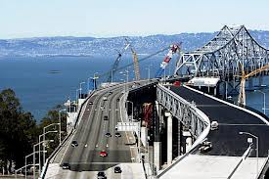
Mitchell’s Musings 8-12-13: Omitted Points
Daniel J.B. Mitchell
Various reports have been appearing in the news media of late that – while describing events and information – leave out critical points. For example, in Inside Higher Ed, an online news magazine, there recently appeared an article about the reluctance of tenured university faculty members to retire, thanks in part to the decline in their retirement accounts due to the Great Recession. But the story is actually more complicated.
Shy of Retiring
When federal law banned mandatory retirement in most occupations, an exception was made for higher education faculty thanks to then-Senator Daniel Patrick Moynihan who had come out of the university world. He argued that the combination of tenure and end of mandatory retirement would lead to faculty staying on the job too long. The law thus included a period in which mandatory retirement would continue to be allowed for faculty and then a study would be made to see if the exception should be continued. In the end, however, the exception wasn’t continued and faculty, just as most other employees, cannot be subject to mandatory retirement.
Here is the missing piece from the reports on faculty who hang on beyond when they should. At many universities, faculty members have defined-contribution retirement plans, notably TIAA-CREF, which provide no particular incentive to retire, even apart from stock market losses during the recent financial crisis. Such programs are basically tax-favored savings accounts. The longer you stay on the payroll, the more you accumulate in the plan.
Some universities – including my own, in contrast – have defined benefit plans which a) shield retirees from the vagaries of the stock market and b) have retirement formulas that max out and create a strong incentive to retire. I have only anecdotal evidence from my own university but not surprisingly it appears that where you have a defined benefit plan, for the most part retirement takes care of itself. But, of course, such plans are under attack and have been largely dropped in the private sector. If you are an employer and want to have “new blood” – and want to avoid age discrimination suits – you might ask yourself why you don’t have defined benefit pension. But that question is not mentioned in the reports of superannuated faculty.
= =
The Choice of Chair
The news is filled with a kind of contest between two individuals who are said to be the top contenders to be the next Federal Reserve chairman (or chairwoman) when Ben Bernanke retires: Larry Summers vs. Janet Yellen. (Google those names if you haven’t followed the story.) Rather than just posing a personality contest, isn’t the broader question what you want in someone to head the Fed? That issue – when it is posed – often relates to what the new person will do when inflation heats up, although the promised heating up of inflation seems to be ever postponed. So here is what we do know about the Fed and the Fed job.
1) Old fashioned monetarism is dead. Indeed, the funeral occurred sometime in the 1980s, when the Fed kept trying to pick among the various definitions of the money supply for targeting and ended up with inconsistent goals. At that point monetarism really died in practice although we are still haunted by its ghost. The Fed under Alan Greenspan went back to targeting interest rates, not some illusive definition of money, and essentially just pragmatically adjusted the accelerator and the brake with the ebb and flow of the economy.
2) Changing financial institutions not only made trying to define “money” impractical, it also changed what kinds of institutions mattered in a financial crisis. Once upon a time it was just “banks.” But it turned out that nonbanks such as Lehman Brothers were as capable of creating a crisis as conventional banks. Given the changing scene, what is needed in a Fed chair is someone who is committed not to let the financial system fail – we came close in 2008 – and in working to develop mechanisms to make it less prone to failure.
3) Although we like to talk about macroeconomic policy as “monetary and fiscal” policy, fiscal policy requires action in Congress and we have a gridlocked Congress. Moreover, even in the best of circumstances, fiscal policy doesn’t move fast enough to deal with immediate economic downturns. The notion of “shovel-ready” projects that can be immediately implemented to stimulate the economy is a myth.
If projects are truly shovel-ready, they are likely to occur anyway. Hinting to local governments that the federal government might have stimulus funds to pay for them may well delay the projects. A rational local government administrator should stop shovel-ready projects that would otherwise be underway to see if federal money funding replace local.
In short, at the present time, macroeconomic policy is just monetary policy as conducted by the Fed. So we need a Fed chair who will be pragmatic and not be a slave to any model or school of thought. And we need one who won’t dither if another emergency arises. Those are the criteria against which any candidates for the Fed chair should be evaluated. But you don’t find much about these criteria in the Summers-vs.-Yellen stories.
===
Pollster Alternatives
California has two major polls on state (and federal) issues. One of these is conducted by the Public Policy Institute of California (PPIC). Polling about the budget occurs on a regular basis.
Under California state budget practice, the governor presents a budget proposal in January for the coming fiscal year that begins the following July 1. In mid-May, the so-called “May revise” proposal is released by the governor. It is generally the January plan modified based on newer data on state receipts and spending and the economic outlook and on reactions to the original January version. At around the time of the most recent May revise, PPIC took a poll that related in part to the proposed budget. When asked if they generally approved or disapproved of the proposal – which the pollster described – 6% of respondents volunteered that they had no knowledge of the budget and another 5% said they didn’t know if they had an opinion.
All told, therefore, 11% confessed ignorance. That proportion is implausibly small by orders of magnitude. Yet the poll went on to gather opinions on particular aspects of the budget plan such as where priorities should be, e.g., education, social spending, or rainy day fund. So what does that fact tell you? It mainly tells you that pollsters need opinions and will get them even where none exist. Keep that lesson in mind when you read about any poll results on key issues of the day, budgetary or not. You will have to keep it in mind because you are unlikely to read it in your news source.
===
The Chinese Menu
Late last month, articles appeared in the news media about a new law in China that would require adult children to visit (and presumably help support) their elderly parents. Suffice it to say, such a law was seen by Americans as an oddity. But were there any lessons for the U.S.?
China doesn’t have an advanced social security system. However, it has a problem somewhat analogous to the American (and European and Japanese) problem of a bulge coming in its elderly population relative to younger persons. In the U.S., the bulge results from the baby boom/baby bust phenomenon. In China, it reflects the deliberate one-child policy undertaken to limit population growth.
In the U.S., discussion of the elderly bulge issue tends to revolve around increases coming in the cost of Social Security and Medicare. Actuarial calculations, trust funds, and payroll taxes are the lingo through which the discussion proceeds. In other words, since we moved to a system of national rather than family mechanisms to deal with support of the elderly, we discuss the matter in terms of the paraphernalia of those national mechanisms. In China, it is still a family affair.
Note that the unfunded liability that we fret about in the U.S. regarding Social Security and Medicare is also present in China, but in a different way. In China the burden is handled more at the micro level (as it was in the U.S. before the Great Depression). There is an important lesson once you look at the issue for what it is. You cannot make the unfunded liability go away when it is demographic in origin. You can spread it around differently, macro vs. micro. But it is going to be there.
“Fixing” Social Security through privatization – a common remedy proposed by critics of Social Security in the U.S. – doesn’t erase the problem. What it probably would do is ensure that the burden will be distributed less fairly as it was back in the day. Elderly individuals who don’t have families or don’t have families with adequate resources will receive less under such fixes. Others with wealthy families may get more. Unfortunately, “it’s-the-demography-stupid” rarely appears in stories about social insurance.
= = =
Foreign Affairs
The Bureau of Economic Affairs of the U.S. Department of Commerce periodically releases data on the U.S. International Investment Position, i.e., claims on the U.S. by the rest of the world vs. claims on the rest of the world by the U.S. The difference between the liabilities of the U.S. to the world and the assets of the world in the U.S. is the net debt of the U.S. to the world.
Net claims of the world on the U.S. (net liabilities of the U.S. to the world) are now well over $4 trillion. Although the amount bounces around from year to year and quarter to quarter as the chart on the next page from the latest release shows, the long-term trend of an increasing net liability is a continuing process. And it will continue so long as the U.S. goes on buying more from the world (import) than it sells to the world (export). If you spend more than you earn, you must either run down your assets and/or run up your borrowing. In that respect, a country is no different than a household.
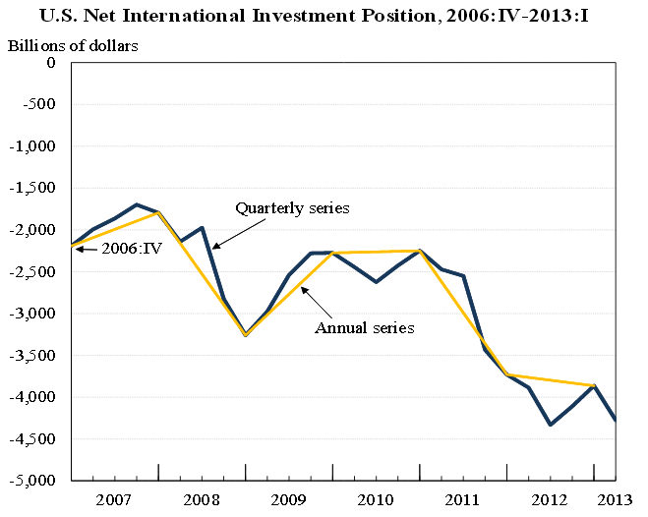
Source: http://www.bea.gov/newsreleases/international/intinv/2013/pdf/intinv113.pdf
Those who fret about the U.S. government budget deficit seem surprisingly unconcerned about the trade deficit and the consequent run up in American net liability. Isn’t it time that someone asked what the end game is for this phenomenon? Or what the effect is on the composition of American jobs? Or about the disproportionately adverse effect the trade deficit has on manufacturing?
There are often complaints about the lack of transparency of information. Yet the international trade and investment information is released regularly for all to see. But apart from a periodic reporting of the numbers themselves, you won’t find much about their implication in the news media. Indeed, that is true of all the cases reviewed in this musing. The information is available. But the implications are between the lines.
Mitchell’s Musings 8-19-13: Never Having to Say You’re Sorry
Daniel J.B. Mitchell
During the Vietnam War – with the country divided and on- and-off race and student riots – came the book and movie “Love Story,” the ultimate in escapist entertainment but with the imprimatur of a Harvard author. The famous line in the film, “Love is never having to say you’re sorry,” is about all that is remembered from the film nowadays: http://www.youtube.com/watch?v=B5-8_1uCzR8. (Never mind that the opposite is true.) An interesting question is whether when you are in charge of something – a government official, a high-level manager in a firm or organization – the saying applies.

I was reminded of the idea that those in charge (almost) never say they’re sorry by a recent incident in California involving cell phones. At around 11 pm a few days ago, I was awakened by a very loud blast from my iPhone – not a ringtone or a sound I had ever heard. When I looked at the phone’s screen,
a message appeared and then disappeared quickly. It was something about a kidnapping somewhere – I couldn’t read it in full before it vanished - and, needless to say, I could do nothing about it in any case.

What was it all about? California had developed an “Amber Alert” system which essentially would blast every smartphone in the state when some official decided that the authorities needed the aid of the public. (It is separate from a system that does the same, but only in cases of natural disasters such as earthquakes.) Needless to say, many folks were annoyed and were unaware that they were opted into the Amber Alert system. And needless to say, the following morning there were instructions posted by IT experts as to how to opt out.

Eventually, the kidnapper was caught and killed in a confrontation, but not in California – in Idaho. No apologies from the powers-that-be resulted. In fact, they officially deemed the capture as a success of the system. Why? The kidnapper had been spotted by a citizen in an Idaho forest who – after returning to civilization – heard about the alert and then reported the kidnapper’s whereabouts to police. But why had the alert been in the news in Idaho? Not really because of the kidnapping but because of controversy over the cell phone system that no one knew about until someone decided to test it.
So, in a sense, the cell phone alert system had led to the capture albeit through an entirely inadvertent chain of events. And never mind that many folks, including yours truly, had opted out of the system to avoid another rude awakening or that a simple ordinary text message, without the blast sound, would have alerted lots of people without precipitating them to opt out. (And a simple text message would not have disappeared before it could have been read.)
Is this just a California story? You could be forgiven for thinking that is the case. There have been a series of disclosures of failures of state government in the last year or so without anyone in authority really apologizing to the public or taking a hard look at what must be systemic problems that caused the multiple failures. Several departments turned out to have “hidden funds,” monies that seemed to be lost in state accounting or were improperly placed or used. Most notable was the department which maintains state parks. During the lean budget years, there were constant threats of park closures and private fundraising was used to keep parks open. But it turned out that the department had more money than it seemed to realize. (The full story of how and why it happened has never been clear.) Top officials resigned. But the underlying problem – how a department could have funds that no one with oversight authority (including the governor) knew about – seems to remain unaddressed. And no one seems to be sorry.
Similarly, a major public construction project is underway to replace a large segment of the Bay Bridge in the San Francisco area. The project has been plagued by falsified inspections, inadequate inspections, and the installation of faulty components that will have to be replaced at major cost. It is unclear at this point whether the new bridge can be opened on or about Labor Day as originally scheduled. Some temporary fixes may allow such an opening but ultimately permanent fixes will be needed. The main reaction of the governor so far was to tell a reporter that “sh*t happens.”
Actually, the only California gubernatorial apology I can remember came from the previous governor – former (and now present) movie actor Arnold Schwarzenegger. In 2005, he sponsored what was termed “the Year of Reform,” a set of four ballot initiatives which the public soundly rejected and which dropped his favorability ratings so low that his outlook for re-election in 2006 looked dim. After the 2005 fiasco, Schwarzenegger said he took “full responsibility” for the outcome. He replaced his key staff with new (and very different) people and apologized to the public in his State of the State address in January 2006.
Perhaps Schwarzenegger was recalling his Hollywood experience; if you are in a movie that fails at the box office, you find a new script for the next one. In any event, he won overwhelming re-election the following November. So apologies and changes in policy seem to work – at least on the rare occasions when they are tried.
Commentator Harry Shearer’s weekly “Le Show” public radio program has a segment called the “Apologies of the Week” in which he reads on the air exactly what the title implies, public apologies. I have never made a count but the vast majority of apologies are not for policy mistakes. They are typically apologies by a mix of celebrities, sports stars, public officials, and an occasional private sector executive, for racist, sexist, anti-Semitic, or homophobic remarks that became public – sometimes through tweets or recordings of what were thought to be private conversations. The apologies are frequently qualified with “if anyone was offended...”
Even when top management is involved, changes in policy are usually not on the table. The CEO of AOL last week apologized for firing his PR director in the midst of a quasi-public conference call for taking a photo of him during the talk. A recording of the call went viral. Irony of ironies, the theme of the CEO’s talk was the need and ostensible implementation of a policy of “transparency.” But the apology, when it came, did not suggest that the victim would be rehired, i.e., that the decision itself was wrong. Just the bad resulting PR and public nature of the firing was wrong.
The inability to reverse course or re-evaluate policy (as opposed to just apologizing) seems to be a characteristic of management in all facets of society, public and private. Academics reading this musing will undoubtedly be able to cite many examples in which university administrators are unable to reverse direction on misguided policies, absent tremendous negative fallout. Apparently, changing direction is feared to be a sign of weak leadership and “flip-flopping.” (Schwarzenegger, as governor, once said in a TV interview that he thought flip-flopping was a great thing – it showed a willingness to learn – but that view doesn’t seem to be the prevailing attitude.) Or maybe there is a deep psychological need to see oneself as always correct.
Clearly, however, there has to be a balance between total consistency and excessive flexibility. There are endless stories and MBA-oriented case studies of private firms that fail due to “bad management.” Jobs and wealth are destroyed in the process of these failures. But typically what is meant by bad management is a series of incorrect decisions. Perhaps what should be meant by the term is a more general inability to reverse bad decisions. In an uncertain world, there will always be decisions made that seem correct at the time but turn out to be leading to failure.
Last week’s musing was partly devoted to the choice for a new Federal Reserve chair that will soon have to be made. I noted that during the 2008 financial crisis, it turned out to be a mistake to let Lehman Brothers fail and thereafter the policy was reversed. You could say the initial decision was “bad management” of monetary policy. But the fact is that no one could have been sure what the consequence would be. Since the decision to bail out financial institutions itself has costs, it would be natural to resist doing so. In my view, what would have been “bad management” would have been an inability to learn from the outfall of that first decision and to continue to let big financial institutions fail.
In a sense, therefore, MBA case studies of successful firms don’t really identify good management – or at least a key aspect of it. If a top executive makes a correct decision and success flows from it, you still don’t know what he or she would have done if the decision had turned out badly. Would corrective action have been taken? Or would the executive have continued to insist that all would be well if the policy were maintained? You don’t know – until “sh*t happens.” And the test is what you do then.
Mitchell’s Musings 8-26-73: The New Nixon Tapes on Wage-Price Controls & the Soviet Trade/Jewish Emigration Issue
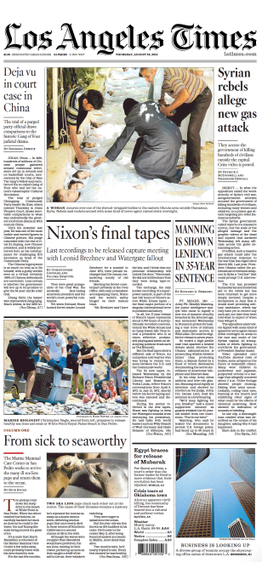
Daniel J.B. Mitchell
The recent release of new Nixon “White House” tapes by the Nixon library and the National Archives for the period April-July 1973 has been a featured story in the news media. Not surprisingly, the focus of reporters digging through the many recordings has been on the then-evolving Watergate affair which was taking up more and more presidential time. But there were other things going on in the world which are also reflected in the tapes including things related to labor market and other economic policy.
In earlier musings, we have utilized tapes from the Nixon, Johnson, and Kennedy White Houses to illuminate matters of economic policy and labor-management relations. The newly-released Nixon tapes cover a period in which there were wage-price controls, a topic of past musings. To recap, a wage-price freeze (Phase I) was first imposed in August 1971. It was followed by Phase II controls three months later which involved regulations governing allowable wage and price increases. The controls were relaxed in January 1973 – in Phase III - and so the new tapes deal with experience during that period.
The decision to impose controls was intertwined with foreign economic policy regarding exchange rates and trade. Until August 1971, the U.S. dollar was a key element in the post-World War II Bretton Woods international monetary system of fixed exchange rates. Under that system, the dollar was supposed to be maintained in a fixed relation to other major currencies and to gold. A run on gold by foreign central banks in 1971 triggered a decision by the Nixon administration to end the gold link to the dollar and the dollar’s fixed link to other currencies. Since that decision would likely lead to dollar depreciation and rising prices of foreign traded goods, there was concern that there would be an inflationary domestic effect. And since inflation was already a concern at the time, wage-price controls were seen as a way of holding the rate of price increase in check.
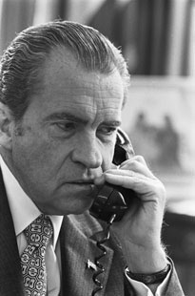[Type a quote from the document or the summary of an interesting point. You can position the text box anywhere in the document. Use the Text Box Tools tab to change the formatting of the pull quote text box.]
During the Phase II period, a kind of mini-Bretton Woods fixed exchange rate arrangement was re-established known as the Smithsonian System (with a devalued dollar). But shortly after Phase III came into effect, the dollar again came under pressure in foreign exchange markets. The short-lived Smithsonian System was abandoned, leading to flexible exchange rates and further dollar depreciation. Inflation was therefore again a growing policy concern during the period of the newly-released tapes. Indeed, in June 1973, the President imposed a second freeze.
There are many new tapes that have been released and the process of searching through them for information related to wage-price controls and other economic problems is difficult, especially since the search engine provided is limited. However, an initial search through just one tape revealed an interesting element during Phase III. It appears from the recording that as early as April 1973, the President was beginning to think about a second freeze.
In a phone conversation with Treasury Secretary George Shultz of April 18, 1973, he received a briefing on ongoing negotiations with Congress about renewing the Economic Stabilization Act, the law which permitted the imposition of wage-price controls. Shultz was never keen on the imposition of controls when the idea first surfaced. But given the program’s existence, he didn’t want it to disappear abruptly. So despite a variety of constraints on presidential authority and congressional demands for certain requirements in the proposed bill, he recommends in this phone call that the President go along with the deal that is available.
A foreign trade matter affecting the Soviet Union also comes up in the conversation. Senator Henry “Scoop” Jackson is pushing for an amendment that would deny “most-favored nation” status to communist countries that don’t permit free emigration. (Most-favored nation status means that a country will get the same lower schedule of tariffs that most other countries receive. Contrary to the name, most countries are most favored.) Jackson’s amendment – which eventually became the Jackson-Vanik amendment signed by President Ford in January 1975 – was aimed at penalizing restrictions imposed by the Soviet Union on Jews (and others) who wanted to emigrate. Nixon was afraid the Jackson trade amendment would scuttle a planned summit conference with the Soviets. In the end, the amendment was not enacted at this time and the summit was held.
Nixon tells Shultz that it will be bad for American Jews if the foreign trade amendment kills the summit. Nixon says he understands why “professional Jews” such as senators Javits and Ribicoff favored the amendment. But Jackson should realize, he says, that Jews will be blamed if there is no summit. The President has another phone call with Secretary of State Henry Kissinger the next day in which he says much the same thing and says to Kissinger he will blame the Jews and won’t be afraid to use a little anti-Semitism if the summit is killed because of Jackson. Kissinger seems to be in accord with Nixon in this phone call. Readers of this blog will recall a previous musing discussing an episode and recording in which Jews at the U.S. Bureau of Labor Statistics are suspected by Nixon and his staff of manipulating economic statistics to embarrass him.
You can hear a recording of both conversations – Nixon-Shultz and Nixon-Kissinger – at:
http://www.youtube.com/watch?v=z3q6gqSoH4U
As noted above, the news media are mainly combing the tapes for Watergate-related revelations. But I will continue to examine them for insights into policies affecting the labor market and other economic affairs in future musings.
Mitchell’s Musings 9-2-13: Bits of Wisdom

Daniel J.B. Mitchell
I’m going to refer to Bitcoins below, but let’s start with an observation. Monetary policy is important. No one really doubts that proposition. As we noted in an earlier musing, much heat is being generated by the alleged competition for chair of the Federal Reserve (when Ben Bernanke’s term ends) between Janet Yellen and Larry Summers. Monetary policy is particularly important in the U.S. at present because with Congress gridlocked and a debt ceiling deadline looming, there is no effective U.S. fiscal policy.
For reasons that seem embedded in American history, there have long been controversies over money that seem not to have counterparts in most other countries. For example, there was the free silver movement in the late 19th century – a battle essentially over whether the U.S. should have a gold-backed or silver-backed currency. When the U.S. temporarily departed from gold under Franklin Roosevelt and when it permanently departed from gold under Richard Nixon, there was more controversy. Money nowadays is backed by nothing, a fact that seems to irk many people in the U.S. and gives rise to conspiracy theories. In contrast, the euro is backed by nothing and no one in Europe seems upset. The pound is backed by nothing and no one in the U.K. seems to care. The yen is backed by nothing and no one in Japan sees anything wrong.
In other countries, the fact that the local currency is created out of nothing by a central bank and yet everyone goes along with the use of the currency for transactions, wealth, etc., isn’t a problem that stirs emotional political frenzies. There may be disagreement about how well the central bank is carrying out its monetary policy, but that is another issue. The U.S. position is rather unique, therefore, which is curious because whether you are an atheist who believes in the Big Bang or a fundamentalist who believes in Biblical creation, you believe that the entire universe was created out of nothing. (You disagree only on the timing.) If the entire universe could be created out of nothing, why not the dollar?
So now let’s bring in Bitcoins, a “virtual currency” created out of nothing. The news media have carried stories on the creation of Bitcoins by a non-government source and how they “work.” There have also been stories about their potential for illicit money laundering which has attracted official regulatory concern, an issue we don’t take up here. But what lessons do we learn from Bitcoins?
Lesson #1: If enough people accept the idea that something has value, it does. The something doesn’t have to be “backed” in the conventional sense of that word, i.e., guaranteed to be interchangeable at a fixed price into something else (such as gold). If you are a libertarian of the variety that doesn’t like the Fed because it creates something out of nothing (and who longs for the gold standard), but you are also a libertarian that likes Bitcoins because they have been created out of nothing by something other than the Fed, you are carrying two contradictory thoughts in your head. Human beings have a remarkable capacity to hold contradictory thoughts at the same time, but still...
Lesson #2: The Bitcoin is not a very good currency because although some people “believe” in it, not enough do for it to have a relatively stable value. Take a look at the two charts I downloaded on August 28th from bitcoincharts.com, a website that seems to have some relation with bitcoin.com.
====================================================================================
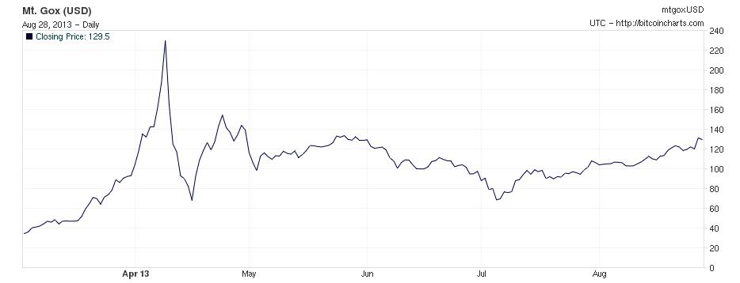
The price of a Bitcoin is shown above on the right axis. The closing price at the latest date is 129.5 dollars per Bitcoin.

Widely varying prices are shown above for locations at varying distances from downtown Los Angeles.
===================================================================================
Absent an official entity that puts a kind of stamp of approval on a currency, most people won’t “think” in that currency. They won’t set wages or make other long term contracts in the currency. And so the result is you get big short-term fluctuations in the currency’s value over time or even agreement on what that value is at any moment in time.
All the modern dollar really promises is that you can buy a dollar’s worth of products with it. But that amount is relatively stable within the U.S. (simply because the dollar is the official currency of the U.S.) because people do set wages and prices in the dollar and make long term contracts (mortgages, bonds, etc.) in it. Why do people do that? The phrase used by economists is “network economies” which simply means they do it because everyone else (in the U.S.) does it. Note that the dollar is not stable in terms of what it will buy in other countries because folks there think in, and contract in, their local currency and not the dollar.
The euro experience is particularly useful here as an illustration. When people in diverse countries around Europe were told that their official currency was no longer going to be the franc, mark, lire, drachma, etc., they all began doing business in euros. Why? Because they knew everyone else would be doing so. And how did they know? Because it was announced by official institutions to which people normally pay attention. Creating the euro was a coordination success because there were official coordinators in the various countries (governments, central banks).

Lesson #3: Even unofficial virtual currencies such as the Bitcoin can’t seem to escape conspiracy theories. Check out “Bitcoin: The New World Order's Plot for a World Currency?” if you don’t believe me.
Does all of this matter? You bet it does. Fuzzy understanding of what money is (and isn’t) infects American politics and therefore impedes making appropriate monetary policy. We can have various views about what monetary policy is appropriate right now in the U.S. to foster the current recovery and lower the rate of unemployment. We can think the Fed is doing a good job or a bad job. But it is hard even to have that conversation when fantasies about money persist.
Mitchell’s Musings 9-9-13: Nixon’s Wage-Price Controls and their Watergate Entanglement
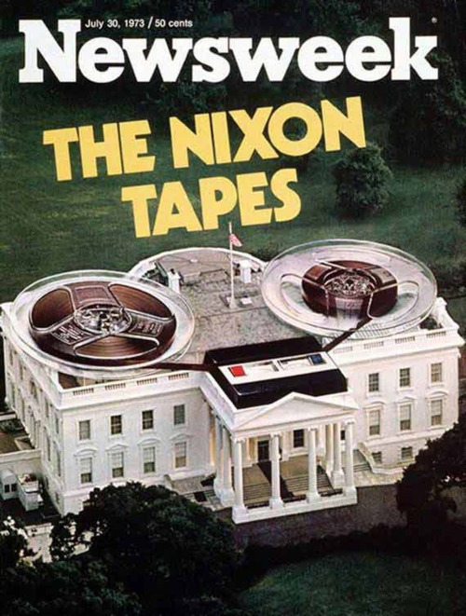
Daniel J.B. Mitchell
In past musings, we have utilized recordings from the Kennedy, Johnson, and Nixon administrations to illuminate various employment-related policies. After the Watergate affair exposed the secret taping of “White House” conversations in the Nixon years, prior recordings of earlier presidents became known and are also now available. We noted that recently a new batch of recordings from 1973 was made public through the Nixon Library. The new recordings add to our understanding of economic policy of that era. Our musing of August 26 utilized the new recordings to discuss such policy.
Not surprisingly, reporters began sifting through the newly-released tapes, looking for new revelations related to Watergate, the Vietnam War, and other major issues of that period. Economic policy has not been emphasized in those efforts, but is also an important part of the historical record. In particular, what do we learn about the wage-price controls program then in effect?
By way of background, the President had imposed wage-price controls in August 1971, starting with a 90-day freeze on wages and prices known as Phase I. It was followed in November of that year by Phase II with more flexible controls administered by a tripartite (labor, management, public) Pay Board. At the time, inflation was widely seen as some combination of “demand-pull” and “wage-push” (more politely at times termed “cost-push”). The notion was that major prices were “administered” and could be seen at the macro level as markups over wage costs. Wages were viewed as being set in key big union settlements when set patterns for other settlements and, ultimately, for nonunion wages. If wage increases could be held down, there would be less inflation.
Phase II lasted until January 1973. At that point, a more relaxed Phase III came into effect. Phase III was seen as a pathway to eventual decontrol. However, inflation remained a problem, aggravated by a falling U.S. dollar in international currency markets as the remnants of fixed exchange rates were ended. Food prices in particular began to rise. The problem was that commodity prices for food at the wholesale level were market-driven and not “administered.” They also had little to do with wages. Attempts to set price ceilings on food could easily create shortages.
On June 13, 1973, however, President Nixon went on TV and imposed a second (60-day) freeze, this time on prices only. Wages were not frozen but were supposed to remain moderate under Phase III guidelines. Obviously, rising prices – especially food prices – had created political problems for the administration. But given the propensity for ceilings on food prices to create shortages, why did Nixon go the price freeze route? Wouldn’t his economic advisors have counseled against such a move?
I have just begun exploring the newly-released White House tapes. The process is made difficult because the search engine available for exploring the tapes is clumsy. Nonetheless, it is clear from early searching that Watergate was becoming an all-consuming focus of presidential attention by June 1973. Congressional hearings on Watergate were underway and creating headlines. Former White House counsel John Dean was giving damaging testimony. The President was looking for ways of showing he was still in charge of national and international affairs and that Watergate was just a political/news media diversion from more important matters.
Watergate aficionados will recognize many of the names mentioned in the various phone calls we have selected for this musing; others who are less familiar with Watergate can Google the names for details. The key thing that comes through is the tone of the conversations, all but one of which occurred immediately after the second freeze TV broadcast. (One conversation occurred the next day.) Three events are intertwined with Watergate throughout: 1) the speech announcing the second freeze that preceded the calls (and the freeze itself), 2) a deal the same day as the freeze in Paris with the North Vietnamese that was supposed to further the Paris Peace Accords on the Vietnam War, and 3) an upcoming summit conference with Soviet leader Brezhnev. (Nixon also references his opening to China.)
The first call is with Alexander Haig, White House chief of staff. The freeze and freeze speech are depicted as proving that President Nixon is back in charge, as restoring confidence in the President after the Watergate disclosures, etc. In a later call, Nixon talks with pollster Louis Harris. Nixon explains to Harris that he froze prices but not wages because recent wage settlements have not been inflationary. Why should he freeze wages and antagonize Frank Fitzsimmons, the Teamsters president, or United Auto Workers president Leonard Woodcock? (The Teamsters were then negotiating with the major trucking firms; the Auto Workers would soon be negotiating with the “big-3” American automobile manufacturers.) If food prices kept rising, these two union officials couldn’t negotiate reasonable settlements, hence the price-only freeze. Nixon also mentions a plan to restrict exports of soybeans and other food commodities to hold back food prices domestically by cutting off foreign demand.
The President also has a call with Charles (“Chuck”) Colson, special counsel to the president. Nixon was pleased with what Louis Harris had told him about the freeze speech and indicates Harris and another friendly pollster should get the president’s political polling contracts as a reward for being helpful. During that call, Nixon reveals that he overrode both Treasury Secretary George Shultz and Council of Economic Advisors chair Herbert Stein in imposing the second freeze. Colson and Nixon see the freeze and the decision to override his economic advisors as politically necessary.
A second call with Haig takes place. Haig gives Nixon much the same view as in his first call about how successful the freeze speech had been in demonstrating that the President was in charge. They discuss how Kissinger, who is returning from the latest Paris deal with North Vietnam, should talk only about foreign affairs and should not say anything about Watergate. (Nixon says Kissinger should be ordered not to discuss Watergate.) Finally, there is a lengthy call with H.R. Haldeman on Watergate strategy the day after the freeze speech. Again the theme of diverting from Watergate is referenced. Haldeman was Haig’s predecessor, but he had to step down earlier because of involvement in the Watergate affair. However, that call indicates that he was still acting as an advisor.
I have put the first Haig call and the Harris call at: http://www.youtube.com/watch?v=NBpKzRPoA3M
The Colson, second Haig, and Haldeman calls are at http://www.youtube.com/watch?v=oTrj0duQeww. (Just the freeze excerpt from a much longer call about Watergate strategy is included in the Haldeman call.)
Obviously, any presidential economic policy undertaken for whatever reasons has political ramifications and the wage-price controls program under Nixon was no exception. The initial 1971 decision to undertake controls was controversial among White House economic advisors. However, at the time there was significant support among macro-economists for the decision. By the time of the second freeze, however, there was clearly opposition by key economists with the administration and the freeze became so interconnected with Watergate that its implementation has to be seen as entirely political. Indeed, the President and his non-economic (political) advisors admit as much in their phone calls in the wake of the second freeze speech. In contrast, the various foreign policy initiatives referenced clearly were being undertaken willingly and enthusiastically by Nixon’s international affairs experts such as Kissinger, and were consistent with their initiatives from the pre-Watergate period.
Mitchell’s Musings 9-16-13: Before Nixon’s Second Freeze
Daniel J.B. Mitchell
In last week’s musing, we utilized newly-released Nixon “White House” tapes to examine the decision to impose a second freeze on June 13, 1973 as part of the wage-price controls program then in effect. Some general background on the program and that freeze was included in that musing. A key aspect of the freeze decision was the increasingly-dramatic Watergate affair which by then had already caused resignations of key administration officials. The newly-released tapes suggest that despite whatever outward appearances were being projected, White House attention was heavily focused on Watergate; every other policy – domestic or foreign – was being viewed from a Watergate perspective. Specifically, each policy was being evaluated for its capacity to divert public attention from Watergate and to project an image of a president still in charge and dealing capably with national problems.
The wage-price controls program was no exception to this Watergate focus. Indeed, wage-price policy was increasingly becoming an instrument of political persuasion. Of course, even under more normal circumstances, any presidential policy has a political dimension and the controls program – which began in August 1971, well before Watergate – had also been no exception to that generalization. However, there was a major difference between the controls decision of August 1971, which began with a wage-price freeze, and the second (price-only) freeze of June 1973.
Prior to the first freeze and to the more general decision to impose controls, there was a divergence of views among economic advisors inside and outside the administration about a wage-price regulatory system. Some economists consulted by President Nixon did not favor the decision, especially those with a “free-market” orientation. But others thought some kind of wage-price intervention would be helpful in combating inflation.
The Kennedy-Johnson administration had earlier experimented with a voluntary wage-price guideposts program. Although that effort ultimately fell apart, there was some empirical evidence suggesting it had a temporary inflation-retarding effect (but was later overwhelmed by Vietnam War-era excess demand). Various European countries were experimenting with forms of “incomes policy” under which union and management groups and national governments agreed to standards of anti-inflation behavior.
There was a tendency to view price and wage setting as “administered.” Key union settlements set a general pattern of wage increases. Major firms then had the market power to pass through the resulting cost increases, adding a profit markup. If a wage standard was set, and if firms were held to fixed markups, the inflation process would be controlled.
Because of these earlier and contemporary policies and lines of thinking, some prominent American economists believed that some version of wage-price policy – combined with more conventional macroeconomic measures – might be helpful in reducing inflation. Or, at least, they thought it was a policy experiment worth undertaking. While it is impossible to know the degree to which President Nixon weighed politics versus economic advice at the time, there was a diversity of economic perspectives around in 1971. So a presidential decision to go the controls route was not going against a virtual unanimous opinion in the economics profession. The opinions were in fact mixed.
In contrast, the second freeze had little economic support, either from official advisors of the President or from outside economists. Last week’s musing noted reference on White House tapes recorded just after the June 13, 1973 TV speech by the President to opposition from Nixon’s economic advisors. Treasury Secretary George Shultz and Herbert Stein, chair of the President’s Council of Economic Advisors, were opposed and their advice was being overridden. However, various non-economic aides were telling the President that his speech had been magnificent and would demonstrate to the country that the White House was taking care of national business.
Of course, with the benefit of hindsight, we know that Watergate did not melt away following the freeze speech. We know that the freeze, and the Phase IV wage-price controls that followed, did not have a lasting anti-inflation effect. Indeed, the complex energy (oil) price controls that evolved in Phase IV and were retained after the larger controls program was abandoned led ultimately to shortages and gasoline lines under President Carter. Those aides who were talking to the President immediately after the speech could not have known of these later developments. Nonetheless, there was too much of the “yes-man” in those post-speech conversations from the aides. In my view, there was way too much. The President was being told what he wanted to hear and not what he needed to hear.
Next week’s musing will deal specifically with the televised speech itself. By way of preview, however, the speech was certainly serviceable in terms of style of delivery. But it was not the spellbinder that the post-speech evaluations by presidential aides might lead one to believe. It was not the kind of speech destined to reset the national agenda, particularly since its content went against the advice of both internal and external economic opinion.
That observation leads to an interesting question. What was the President hearing from his advisors before the TV speech? What was the evolution of the advice leading up to the speech? Among the newly-released tapes, we have some indication of that evolution. I have posted some telephone conversation excerpts from before the speech at https://www.youtube.com/watch?v=RdKK6lKmXYE.
The first brief conversation is a phone call of April 30, 1973 from Treasury Secretary George Shultz immediately after the announcement by Nixon of the Watergate-related resignations of John Ehrlichman and H.R. (“Bob”) Haldeman. Shultz calls to express his sympathies to the President. The President is clearly grateful for the call and for Shultz’s remarks. As best we can tell from the call and Nixon’s voice, the President is emotionally upset and perhaps not fully in control. But he insists that he will come to a labor-management committee meeting Shultz will be running that was part of the Phase III controls program. Nixon wants to show he is still in charge and remains an active participant in the program.
A second call – this one with Office of Management and Budget (OMB) Director Roy Ash – took place on May 12, 1973. By this time, it appears that some discussion about imposing a second freeze is beginning to occur. But Ash is opposed to the idea as are Shultz and Stein. The freeze talk seems to be coming from John Connally. Connally, a Democrat, was Shultz’s predecessor as Nixon’s Secretary of the Treasury. (He was no longer a Nixon administration official but – after returning to Texas politics for a time – had switched to being a Republican at around the time of this call.)
The main additional support for a Connally-type step is Alfred Sindlinger, a pollster used by the President who thinks a freeze would have a good “psychological” effect on the country. Exactly what a psychological effect (as opposed to an economic effect) was supposed to mean is not clear from the call. But it seemed to involve the idea of the President showing he was still running the country and taking care of the public’s business. Ash notes, however, that it is easier to get into a freeze than to chart a graceful exit. And Nixon notes that a freeze was tried back in 1971 and now he seems uncertain that it had been a good idea.
The third conversation of May 20, 1973 takes place between President Nixon and his Chief of Staff Al Haig. Most of the conversation is related to the Watergate affair but economic matters come up in the excerpt provided. Haig says Phase III wage-price controls now have to be evaluated in the light of Watergate. Connally wants a freeze, but Haig can’t get Shultz and Stein to move away from opposition to any such move. Haig is not necessarily in favor of a freeze but he wants the economic advisors to think politically.
Nixon says that sometimes you have to do things for political reasons - even if there are no good economic justifications - and his economic advisors, including Ash, should recognize that fact. Haig says the administration might eventually need to follow the Connally position and impose a freeze. Nixon indicates that a freeze might be necessary to buoy up the country for political purposes even if the economic effects are bad.
A second Nixon-Haig call that same day reiterates these views. Nixon says in that call that the move to relax controls in Phase III had been disastrous. It appears from this conversation that Shultz’s Deputy Secretary William E. Simon favored stricter controls in contrast to his boss and his letting his disagreement with Shultz be known. Nixon wants to put Connally in charge of energy policy – essentially oil and gasoline prices. He does not want Vice President Agnew to be involved in energy policy since he (Agnew) knows nothing about the subject unlike Connally. Giving the job to Agnew (who was later to resign because of a scandal unrelated to Watergate) would be a “loser.”
The final call takes place just before Nixon’s second freeze TV speech. The President talks to Shultz – whose views he has now overridden. Shultz is being a Good Soldier, nonetheless, and will publicly support the freeze. But in the call he doesn’t endorse the idea; he just is going along with presidential policy. The only concession Nixon has made to Shultz was to exempt rents from the freeze.
Nixon wants to say that the reason for the exemption is that rent controls cause slums. Shultz knows that while that impact might occur in the long run if rent controls were retained indefinitely, it is unlikely to be the result of a 60-day freeze. The housing stock will not fall apart in two months. He suggests that a better rationale for the exemption would be that rents were not rising rapidly and were thus not inflationary. That suggestion seems to be typical of Shultz’s mode of advising Nixon which has been noted in earlier musings. Shultz does not contradict the President. Instead, he suggests an alternative view.
In short, the new tapes reinforce the idea that as Watergate began to engulf the White House, decision making in the economic sphere, specifically on the wage-price controls program, became distorted by a desire to divert public attention from the scandal. In the end, the second freeze appeared to be a thrashing around of policy rather than a carefully considered decision. Nixon’s political advisors might have thought the second freeze and the speech were great accomplishments that would shift the public off Watergate. That has not been the verdict of history.
Mitchell’s Musings 9-23-2013: President Nixon’s Second Freeze Speech
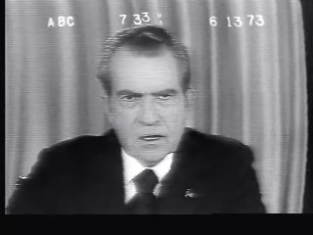
Daniel J.B. Mitchell
For the last two weeks, these musings have been devoted to a decision by President Richard Nixon during his 1971-1974 wage-price controls program to impose a second freeze on June 13, 1973. The controls program had begun with a 90-day freeze on wages and prices in August 1971, which became known as Phase I. A more flexible system of wage-price controls followed in November, Phase II. An attempt to relax controls was put in place as Phase III in January 1973. However, rising inflation – especially of food prices – led to a decision to impose a second, price-only freeze for 60 days in June. The controls program thereafter implemented Phase IV controls which were essentially abandoned in 1974, leaving only a regime of price controls on oil and gasoline.
We have noted that a major difference between the first freeze and the second was in the kind of advice from economists the President was hearing and in the political background. There was a range of opinion on the imposition of some kind of wage-price policy at the time of the 1971 Phase I freeze. Prices and wages were seen as “administered” (in the case of wages by unions in key sectors; in the case of prices by large oligopolistic firms). Prices and wages were thus viewed as subject to government intervention by many macroeconomists of that era. The Kennedy and Johnson administrations had pursued a voluntary wage-price policy which fell apart under demand pressure. European countries also had versions of “incomes policies” that involved similar programs and assumptions.
The upshot is that in 1971, there were “respectable” economists on both sides of the issue. In contrast, in the case of the second 1973 freeze, we have shown - based on newly-released White House audio tapes - that the chief economic advisors to President Nixon opposed the action. Freezing food prices was especially risky since controls of such prices can easily produce shortages. Some political advisors and pollster-types, however, favored a bold step against inflation. A major factor in the 1973 decision and the political advice was the unfolding Watergate affair.
There was no Watergate affair in August 1971. By the time of the second freeze, however, key administration officials had already resigned due to the scandal. Thus, taking bold action was seen by the President and those who favored a freeze as a way of diverting public attention from Watergate and of showing that the President was still in charge and handling the nation’s concerns.
In our previous musings, we looked at the views expressed by administration officials in conversations with the President immediately after his TV broadcast announcing the second freeze. He was essentially being told that the speech was a roaring success. We looked also at conversations leading up to the speech and the period of time in which the President moved from doubts about imposing a freeze to implementation. What we haven’t discussed so far was the speech itself.
I have posted the televised speech which was carried on the major networks of that period at: http://archive.org/details/NixonsSecondFreezeJune131973 [Click on the player at that address.]
Also at http://www.youtube.com/watch?v=z7DpvCOdOcg [Part 1]
and
http://www.youtube.com/watch?v=f8bu0VDHWF8 [Part 2].
In keeping with the notion of appearing to be in charge, President Nixon began by saying he would be announcing “strong actions” on the economy. After that opening, he pointed to positive aspects of the U.S. economy, but then noted that there was one important problem: inflation, especially of food prices. In terms of delivery, the speech was not exceptional, although the presentation generally improved as the speech progressed. The President read from sheets of paper (never a great approach to public speaking) and mispronounces or stumbles over some words early on. There is nothing terrible in those slips – the speech delivered the message – but the accolades we noted from his advisors after the speech were excessive.
The freeze described by the President covered all prices, but exempted wholesale foodstuffs (commodities). As such, the danger of shortages was inherent in the plan since rising wholesale prices might bump up against retail price ceilings. Rents were exempted, apparently - as we have shown in our earlier musings - to appease Treasury Secretary George Shultz who opposed the entire freeze idea. Wages were exempted, officially because wage settlements were seen as not inflationary.
There were two elements, however, in the wage exemption. Given the focus on food, the wage impact on those prices was indeed decidedly limited. Gyrations in food prices have their roots in the wholesale commodity markets. This fact is evident in that wages do not gyrate and retail food prices do; the gyrations are essentially pass-throughs of the wholesale costs. But there was also the Watergate-related consideration. Freezing wages would have been controversial and would have created opposition.
From the political viewpoint, the idea was to undertake a policy that would be popular and not a source of immediate controversy. In particular, organized labor – a much more potent political force at that time than now – would likely not oppose a price-only freeze and might even be supportive. But labor would surely object to a freeze covering wages. From a regulatory viewpoint, a variety of problems would have opened up regarding interruption of contractually scheduled union pay increases, treatment of incentive bonuses, costing of employee benefits, etc. These issues were present and had arisen in Phase II, but the Phase II mechanisms for dealing with them were no longer in place thanks to the Phase III relaxation of controls.
The speech went on to indicate that after the freeze, a new Phase IV that would somehow be more effective would be implemented. There was no real description of what that new phase would entail, probably because there was no plan in the ready when the speech was delivered. The President made a statement that wages and prices would be treated “consistently” in Phase IV, but it is unclear what such treatment would involve. He said that both food and gasoline prices would be the special targets of the Phase IV program. Phase IV was described as both more strict than Phase III and yet designed to proceed to an eventual decontrol.
Phase III – like the forthcoming Phase IV - had also been intended as a move toward decontrol. But as our earlier musings demonstrated, in private, President Nixon saw the Phase III implementation and effects as a disaster. Exactly how Phase IV would avoid a similar disaster, move toward decontrol, and yet be more effective in restraining inflation, was not specified.
When controls were implemented initially in 1971, there were really two economic problems being addressed. On the one hand was inflation. But on the other hand, there was the unraveling of the Bretton Woods fixed exchange rates system for international currency markets. In the same speech in which he announced the Phase I freeze in 1971, President Nixon announced he was ending the dollar’s gold guarantee, effectively terminating Bretton Woods and letting the dollar float (down). A new fixed exchange rate system was implemented shortly after Phase II came into effect. But it fell apart at around the time that Phase III was announced.
In short, there remained a linkage between domestic wage-price controls and international economic policy. In his June 1973 freeze speech, the President continued that link by announcing controls on exports of food products. If U.S. food markets were cut off from foreign demand, U.S. prices of food at the wholesale level would be lower than otherwise. Note, however, that other things equal, blocking exports would tend to reduce the demand for the dollar, possibly lead to dollar depreciation in the international markets, and therefore result in higher prices of other traded goods. There is some recognition of this problem in the speech in that the President indicated that - in the long run - exports were a Good Thing, but in the short run he was putting “the American consumer first.” He also asked Congress for authority to reduce tariffs, thus increasing imports and lowering prices of imported goods. Again, there could be opposing effects through the dollar/exchange rate connection, but those impacts were not discussed.
The speech included appeals to Congress to avoid unnecessary spending, to speed up construction of the Alaska pipeline, and to undertake various actions regarding farm policy. Throughout the speech, the President kept indicating that wage-price controls should not be permanent. Controls should not be a “narcotic.” To some extent, these anti-control statements conflicted with the thrust of the speech which was announcing a tightening of controls.
Finally, the President departed from the economic themes and referenced peace in Vietnam (which we know in hindsight was a lull, not a permanent settlement between North and South Vietnam) and an upcoming summit conference with the Soviets. At the end of the speech, the President says that peace, prosperity, and the end of inflation could be achieved by “working together.” We know from the White House tapes referenced in the previous musings that “working together” could be taken to mean avoiding the divisive and diversionary Watergate affair. If Watergate could just be forgotten, the larger goals could be achieved. Despite the advice of the President’s political advisors which the tapes reveal, the 1973 freeze speech did not lead to a downplaying of Watergate. And the lack of supportive economic opinion helped ensure that there was no such political effect.
Mitchell’s Musings 9-30-13: No Comment...Please!
Daniel J.B. Mitchell
Recently, it was reported that Bill Gates admitted that forcing you to type “cntrl-alt-delete” to start your computer was a “mistake.” Unfortunately, it’s a mistake that has yet to be corrected. The admission of a mistake does not necessarily result in a correction. However, some mistakes in the computer/internet world are apparently more difficult to correct than others. One of them is the practice of most news media nowadays to allow more or less unfiltered reader comments to appear on articles published on their websites.
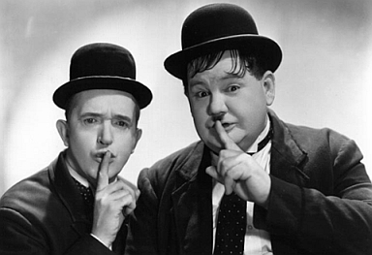
Note that back in the day, when print was the main medium for detailed news, there was only letters to the editor, letters which somebody at the publication selected. Those older outlets for comments still exist and, of course, if you read such letters, you are only reading what someone thinks was worth publishing. But it is worth noting that the entire publication has been subject to some screening to provide “all the news that’s fit to print.”
With the arrival of the internet, however, it has become unfashionable to think that anyone should screen anyone else’s views. Notions of the “wisdom of crowds” (Google the phrase) are seen somehow to suggest that if many people opine, the net result will always be better. The problem is that while every opinion is “information,” some information is better than other information. In fact, some information is just wrong. Moreover, the idea of “the wisdom of crowds” does not override the basic statistical concept of having a representative sample. Those who chose to opine, say on a particular news item, may not be a representative sample of the larger population or even of readers of the item. Furthermore, absent control, false impressions can be generated about what the representative opinion actually is.
It is easy to “vote” more than once under different names using the comment option. And the process requires no identification of the author. In contrast, letters to the editors typically use real names and some indication of the writer’s location. Lack of verification and lack of representative sampling is a fundamental problem of websites such as Yelp and similar rating services. The fact that such services may be profitable, i.e., that people use them and rely on them, is an illustration of the problem, not an argument for their validity.
There is a difference, however, between Yelp and the comments from the often-anonymous authors which appear on news websites. You don’t have to use Yelp. In contrast, the current practice of many news sites is simply to follow the news item with whatever comments appear. You have to avert your eyes to miss them in some cases. In others, you may have to click on a comment button under the news item, a better option, but one that nonetheless closely associates the comments with the article.
So why do news media have relatively unfiltered comment sections when they apply editorial discretion to everything else? I doubt that there have been careful marketing surveys that show that absent the comment option, readership and ad revenue will fall substantially. I doubt even more that any such study was done when the practice of unfiltered comments was first initiated. I suspect that the news media have unfiltered comments because everyone else does and it has become a standard practice. Once a norm is established, deviation from the norm can become difficult or at least it can be perceived as difficult. And there is the handy rationale for editors that since readers surely know that the comments are relatively unfiltered and unrepresentative, no harm is done.
Recently, however, one publication, Popular Science, decided that there was harm done and announced it would discontinue providing the comment option. It noted some research indicating that reader views are influenced (unduly) by shrill, uninformed comments even though readers know that anyone can comment.
...A politically motivated, decades-long war on expertise has eroded the popular consensus on a wide variety of scientifically validated topics. Everything, from evolution to the origins of climate change, is mistakenly up for grabs again. Scientific certainty is just another thing for two people to "debate" on television. And because comments sections tend to be a grotesque reflection of the media culture surrounding them, the cynical work of undermining bedrock scientific doctrine is now being done beneath our own stories, within a website devoted to championing science...
You can hear a radio interview on this subject with the editor of Popular Science at: https://www.facebook.com/photo.php?v=10151972910806522
Note that anyone is free to establish a blog or other social media account, to link to articles on the web, and to make any unfiltered comment about the articles he or she wishes. There is no free speech issue here. You can say what you like and can do it anonymously if you want. But there is no entitlement to appear on someone else’s website.
Why am I putting this commentary on a blog for EPRN? Because the kinds of issues discussed here – employment policy, immigration, budget priorities, etc. – are inherently those which, when they appear in the news media, particularly attract angry discussion. For example, below are some comments that
appeared attached to a San Francisco Chronicle article on the current Congressional budget stalemate:
===========================
SayWhatIThink
11:33 AM on September 27, 2013
"Congratulations Democrats, you are turning 401Ks into 201Ks and the US a second-rate Country..YET AGAIN!!!!!"
My guess is that Mr. Logs does not understand that it was the republicans and their attempt to defund ACA that caused the economic uncertainties that resulted in the recent down turn in the stock market.
Almaviva
11:32 AM on September 27, 2013
Congratulations republicans, you are bringing instability to the free market economy. Investments are losing value because of your silly hissy fits.
gcg
11:25 AM on September 27, 2013
Republican governance ........ oh crap, I'm laughing so hard at my phrasing that I can't even continue.
LincolnLogs
11:17 AM on September 27, 2013
The economic instability called the Obama Recession created by Democrat's obsession with "Social Justice" has been exacerbated with the Democrat's obsession with gov't control of the Health Industry , is already having an effect on the lives of all Americans. The stock market is down and millions of investments have already taken a hit, and millions are still out of work, only part time, or given up.
Congratulations Democrats, you are turning 401Ks into 201Ks and the US a second-rate Country..YET AGAIN!!!!!
===========================
Here are some comments from an article of September 26th in the Sacramento Bee dealing with a computer problem that delayed many unemployment benefit checks:
===========================
 Gretchen1
Try and FIND a job, buster. I've been looking for almost three years, and I have a Bachelor's degree. I take temp jobs whenever I can get them, but they're not permanent. Get a life, and grow UP. You need to.

Reader6789
Gretchen1 you are right. California has a tough labor market and it is beyond hard looking for and obtaining a job. You hang in there. Good luck on your job search.
iimki
Listen to you. You are so rude. Read your comment. People pick up on your attitude and do not want a person like you working for their company, that's for sure, that's why no one wants to hire you. You called Socipathic001 buster, told him to get a life, and grow up. You would never last one minute where I have worked, no f ing way. HR never hires people that are not liked. Everyone sees this about you, you are the reason you don't have a permanent job. If you ever worked where I worked, as a temporary because you can never be anything else, you would be shown the door.
Sociopathic001
Hey, you're the one with the 4+ years of liberal education and an AS in computer networks.
You tell us why it's so hard to get a job.
I'm intimately familiar with the computer field, so don't have to "find" a job, I already have one.

Reader6789
Let's hope you never have to file a claim for benefits.
iimki
It's not hard to find a job. I never had any trouble finding excellent full time jobs. However, if a person rubs people the wrong way, like Grechy, they will NEVER get a full time position. People will not put up with this crap and downing and attacking people. All the comments I have read from Grechy attacking people for no reason, including myself, leads me to believe this person would be very insubordinate. End of story.
===========================
Here are comments on a Los Angeles Times article on the effect of the Congressional immigration debate on Latino voters:
===========================
gordongarlic at 12:40 PM September 27, 2013
non-latino voters are also monitoring their congresspeople to see if they support amnesty for illegal immigrants
gaiapj at 12:39 PM September 27, 2013
Maybe when the Latino's consider themselves Americans and not Hispanic/Latino I will actually care how they vote.
===========================
Did you gain any knowledge after reading these remarks? Did they give you any insights on anything? On the issues themselves? On actual public opinion?
I rest my case. QED and hurray for Popular Science!

http://www.forbes.com/sites/afontevecchia/2013/06/19/did-the-fed-chairman-just-kill-the-bernanke-put-fed-ready-to-taper-qe-this-year/
http://www.bea.gov/newsreleases/national/gdp/2013/pdf/gdp1q13_3rd.pdf
http://research.stlouisfed.org/publications/usfd/20130621/usfd.pdf
http://www.bea.gov/newsreleases/international/intinv/2013/pdf/intinv113.pdf
http://www.sfgate.com/bayarea/article/BART-workers-on-strike-no-service-Monday-4639593.php
The Knowland family which ran the Oakland Tribune was a big factor in Republican politics. See, in particular, Montgomery, Gayle B. and Johnson, James W., One Step from the White House: The Rise and Fall of Senator William F. Knowland. Berkeley: University of California Press. 1998.
http://www.sfexaminer.com/sanfrancisco/plan-your-commute-bart-workers-go-on-strike/Content?oid=2490719
http://www.mercurynews.com/business/ci_23578931/bart-strike-costing-bay-area-economy-more-than
http://www.forbes.com/sites/johngoglia/2013/07/07/san-francisco-777-crash-why-did-so-many-passengers-evacuate-with-bags/
Mary C. Daly, Bart Hobijn, and Timothy Ni, “The Path of Wage Growth and Unemployment,” number 2013-20, July 15, 2013: http://www.frbsf.org/economic-research/publications/economic-letter/2013/july/wages-unemployment-rate/. At this writing, one figure in the paper (Figure 1) does not appear properly. Perhaps it will be corrected.
http://www.latimes.com/business/la-fi-hiltzik-20130721,0,1949777.column
http://www.nationofchange.org/nsa-says-it-can-t-search-its-own-emails-1374761950
489 U.S. 749, UNITED STATES DEPARTMENT OF JUSTICE ET AL. v. REPORTERS COMMITTEE FOR FREEDOM OF THE PRESS ET AL. http://caselaw.lp.findlaw.com/scripts/getcase.pl?court=us&vol=489&invol=749
See http://www.sacbee.com/2013/07/28/5602376/dan-walters-is-bay-bridge-fiasco.html and http://www-wds.worldbank.org/servlet/WDSContentServer/WDSP/IB/2005/12/01/000016406_20051201094022/Rendered/PDF/wps3781.pdf. The Walters column actually refers to a later version of the study that appeared in the California Management Review in 2009: http://www.sbs.ox.ac.uk/centres/bt/Documents/Delusion%20and%20Deception%20in%20Large%20Infra%20projects.pdf.
http://www.latimes.com/business/la-fi-hiltzik-20130728,0,2408536.column.
http://www.insidehighered.com/news/2013/08/06/retiring-professor-says-hes-ready-leave-academe-and-others-should-too
http://www.ppic.org/content/pubs/survey/S_513MBS.pdf (page 28).
http://www.latimes.com/news/nationworld/world/la-fg-china-elderly-law-20130729,0,1879951.story
http://news.harvard.edu/gazette/story/2010/01/love-story-author-erich-segal-72/.
http://blogs.sacbee.com/capitolalertlatest/2013/01/gov-jerry-brown-calls-2013-year-of-fiscal-discipline.html.
http://techcrunch.com/2013/08/13/aol-ceo-tim-armstrong-apologizes-for-brutally-firing-employee-during-patch-all-hands-call/.
http://www.employmentpolicy.org/topic/10/blog/mitchell%E2%80%99s-musings-10-1-12-looking-backward-supposed-bls-labor-data-conspiracy.
For example: http://www.dailynews.com/business/20130816/bitcoin-changing-money-to-change-the-world and http://www.politico.com/story/2013/08/decoding-bitcoin-95595.html.
http://www.activistpost.com/2013/04/bitcoin-new-world-orders-plot-for-world.html.
“White House” is in quotes because not all recorded conversations took place in the White House. In addition, there are many phone conversations in which one party is at some other location.
http://www.employmentpolicy.org/topic/226/blog/mitchell%E2%80%99s-musings-8-26-73-new-nixon-tapes-wage-price-controls-soviet-tradejewish-emi
The Nixon Library has posted a video of the ceremony with Brezhnev in which the two leaders sign various accords at Summit signing 6-21-73, http://www.youtube.com/watch?v=fBAo2Aky74Y .
http://www.employmentpolicy.org/topic/12/blog/mitchell%E2%80%99s-musings-9-9-13-nixon%E2%80%99s-wage-price-controls-and-their-watergate-entanglement.
http://blog.sfgate.com/hottopics/2013/09/26/bill-gates-control-alt-delete-a-mistake/
http://www.popsci.com/science/article/2013-09/why-were-shutting-our-comments

